Guidance for using or adapting IBSS’s AMBA & BGA Excellence Award-winning Carbon Reduction Initiative, “15 Ways in 15 Weeks”

“15 Ways in 15 Weeks” was a semester-long initiative divided into weekly campaigns that drove sustainable positive behavioural change. Each week of the initiative saw themed activities and events across SDG-related topics such as waste management, plant-based diets, ethical finance, and sustainable transportation. The “15 Ways in 15 Weeks” initiative resulted in the establishment of a Sustainable Future Talents student association, 13,000 RMB in charitable donations, and hundreds of healthier choices. For faculty, staff and students, “15 Ways in 15 Weeks” led to positive life changes and new perspectives regarding the contributions individuals must make to achieve Agenda 2030.
Proper use or adaptation of this program under the CC 4.0 License
This program, “15 Ways in 15 Weeks” is a derivative of “15 Ways in 15 Days, Anatomy of Action” by the UN Environment Program and the UN School of Disruptive Design under the Creative Commons where it is licensed under the Creative Commons Attribution-Non-Commercial-Share Alike 4.0 International License, www.anatomyofaction.org. “15 Ways in 15 Weeks” is also licensed under the Creative Commons Attribution-Non-Commercial-Share Alike 4.0 International License and can therefore be used or adapted with proper attribution to both “15 Ways” and the “15 Ways in 15 Days, Anatomy of Action” made.
Questions or further guidance can be sought from Dr. Ellen E. Touchstone, Associate Dean for Responsible and Sustainable Business Education, International Business School Suzhou @XJTLU, ellen.touchstone@xjtlu.edu.cn.

Details of the planning and executive of this initiative

With the goal of raising awareness of the need to build a sustainable future for all, XJTLU IBSS’s Associate Dean for Responsible and Sustainable Business Education (AD, RSBE) Dr Ellen Touchstone introduced the semester-long “15 Ways in 15 Weeks” initiative in March 2021. This was adapted from the open source “Anatomy of Action” initiative created by the UN Environment Program and the UnSchool of Disruptive Design which researched and developed an action map that connects everyday actions to the SDGs. This program suggests micro-actions which, when taken by individuals, will contribute to sustainable macro-changes in the economy and society at large. These micro-actions are framed as lifestyle swaps in five categories: “stuff, fun, move, money and food”.
Each week of the 15-week semester centred on a certain goal, such as trading animal protein for plant protein, with practical activities encouraging experiential learning in this area. “15 Ways in 15 Weeks” was one of the “soft” components of the school’s Carbon Neutral IBSS Initiative, targeting long term behavioural change. Several examples of the weekly activities on offer were a webinar on regenerative farming with a farm family in Canada, a “Meatless Mondays” campaign, an online “Ocean Clean-up Game” with logistics giant CaiNiao, and an ethical investing seminar.
One example of impact created by this initiative is the Sustainable Future Talents (SFT) student organization (Photo 1), formed by students in the first few weeks of this initiative. This tight-knit community quickly became integral to the initiative, and under the AD, RSBE’s supervision, crafted sophisticated social marketing campaigns to raise awareness of how individual behaviour in one “way” can be modified to reduce one’s carbon footprint. The SFT also worked alongside key “15 Ways in 15 Weeks” stakeholders, such as the IBSS Sustainability Committee, other IBSS staff, the Campus Management Office and canteens, as well as local community members, purpose-based businesses and charities, to provide relevant activities depending on the week’s theme. The SFT have expanded their sphere of influence, being invited to present the “15 Ways in 15 Weeks” initiative at the COP 15 Yangtze River Delta Regional Biodiversity and Ecological Civilization Educational Forum meeting in Shanghai, where this information was disseminated to other Chinese higher-education institutions including Fudan, Shanghai Jiaotong, Zhejiang and Tongji universities to replicate and/or adapt. “15 Ways in 15 Weeks” was also shared by one of the SFT students who was a finalist at the academic speech competition at the Forum on Responsible Management and Youth Development Education, a special session of the Education Forum for Asia in mid-September.
Further examples of particularly impactful “15 Ways” activities are as follows:
- Beginning in Week 3 and continuing throughout March, SFT students collaborated with a campus restaurant to offer free coupons for vegan lunches and encourage “protein swaps” through their “Meatless Mondays in March” campaign. The IBSS Senior Management Team also participated through a meatless lunch meeting (Photo 2). The following month, this campus restaurant instituted a permanent vegetarian menu to meet the previously unmet need for plant protein (Photo 3).
- In Week 7 Midterm Week, the SFT offered a quiet activity, environment-themed puzzles with many including the Property Management Office, security officers and cleaning staff joining in to help relieve stress and give their brains a break (Photos 4, 5).
- Week 9’s focus was on encouraging IBSSers to choose the stairs over the elevator to reduce electricity consumption and improve one’s health. Posters and prizes were distributed throughout IBSS to encourage this behaviour change (Photo 6).
- During Week 10, IBSS Supporting Officer for External Relations Shumeng Dong provided a learning experience for students on growing their own food (Photos 7, 8).
- In Week 12, IBSS partnered with the university’s Campus Management Office and local community leaders to offer a training workshop on waste management for faculty which culminated in a sustainable tea break after which the participants put their newly acquired knowledge to use by correctly sorting the waste (Photos 9, 10).
- Week 13’s theme was keeping active by walking or cycling to work or increasing physical activity overall. Nostalgic games and sports equipment were available to use on the plaza outside IBSS (Photo 11).
- “Menstrual Hygiene Day” (May 29) fell in Week 13, so IBSS partnered with Luüna Naturals menstrual hygiene company, winners of the 2021 UN China Social Impact “Empowerment of Women” Award, to organize an awareness event for menstrual stigma and period poverty. Students were encouraged to share their feelings about these issues on a white board in the IBSS lobby and share educational information on social media (Photo 12). Based on the number of shared social media posts, IBSS donated 8000 RMB in organic period products to a Guangxi school.
- Week 14 saw IBSS collaborate with the Tang MaMa charity to provide knitting lessons to faculty, staff and students to create “slow fashion” rather than the “fast fashion” wreaking havoc on the planet (Photo 13). A donation of 5,000 RMB was provided by IBSS to this long-established Suzhou NGO.
With regards to impact, research indicates that 84% of IBSS faculty and staff had heard of the school’s “15 Ways in 15 Weeks” event series, with a high number of these staff also reporting behaviour changes as a result of this initiative. Of these positive changes, the top three reported were using the stairs more (36%), healthy/sustainable food habits (23%) and reduced overall consumption for a lower carbon footprint (19%).
SFT member and Y2 Economics and Finance student Zixin Zhang commented,
“As one of the leaders of Week 9’s activities to encourage taking the stairs, I think “15 Ways” has changed my perspective on IBSS….Our business school for me is no longer only a building, but more like a home. We began to reflect on how to maximize the use of energy in every corner of the IBSS building, as well as the carbon footprint of everyone's daily life. I think the “15 Ways” activity made me think about sustainable development from the perspective of the average person”.
Photos of some of the activities
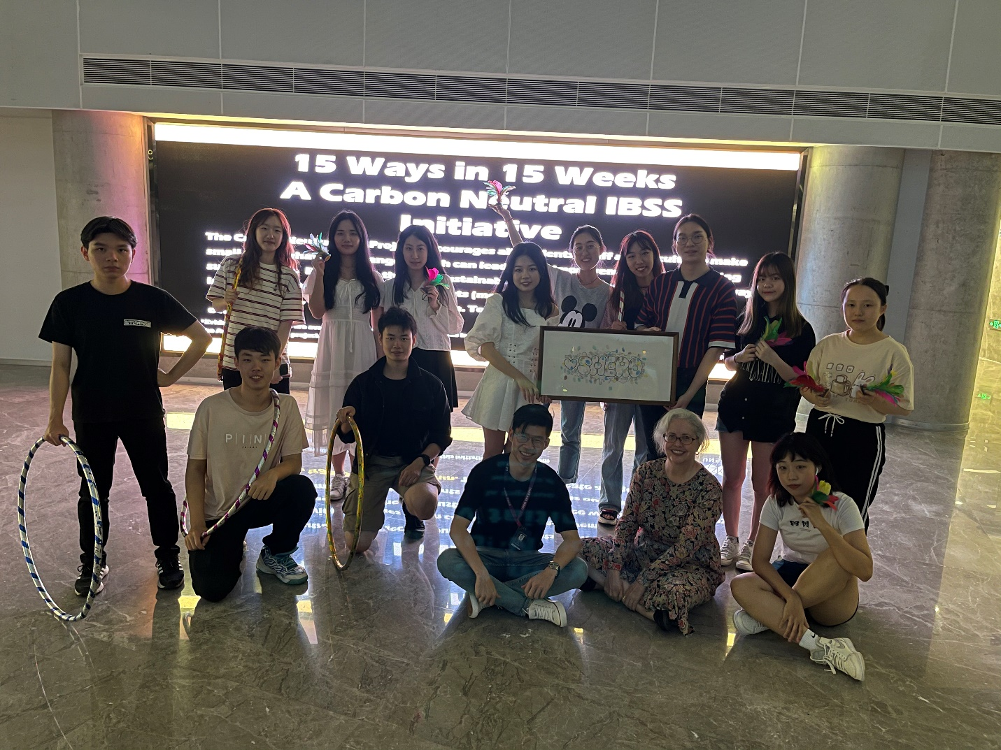

Photo 1: Some members of the Sustainable Future Talents with their advisor, Dr Ellen Touchstone and IBSS Sustainability Committee member, SU Zhenyu
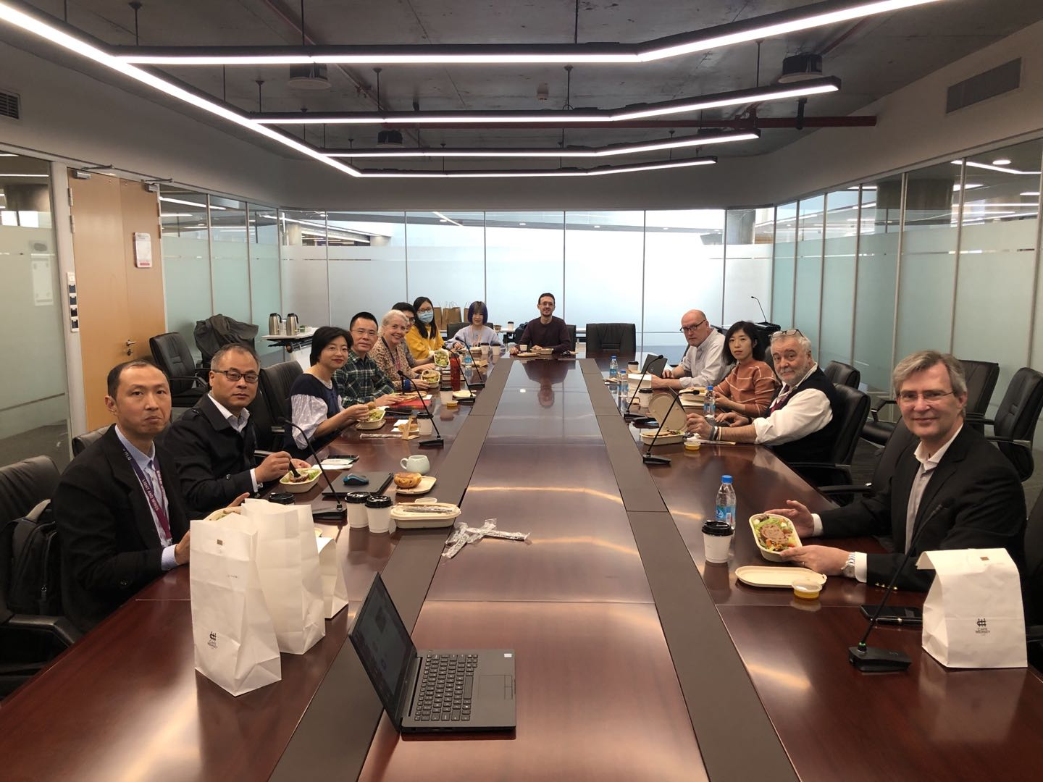
Photo 2: IBSS Senior Management Team participate in the “Meatless Mondays in March” campaign by having a plant-based protein meal during their weekly meeting.
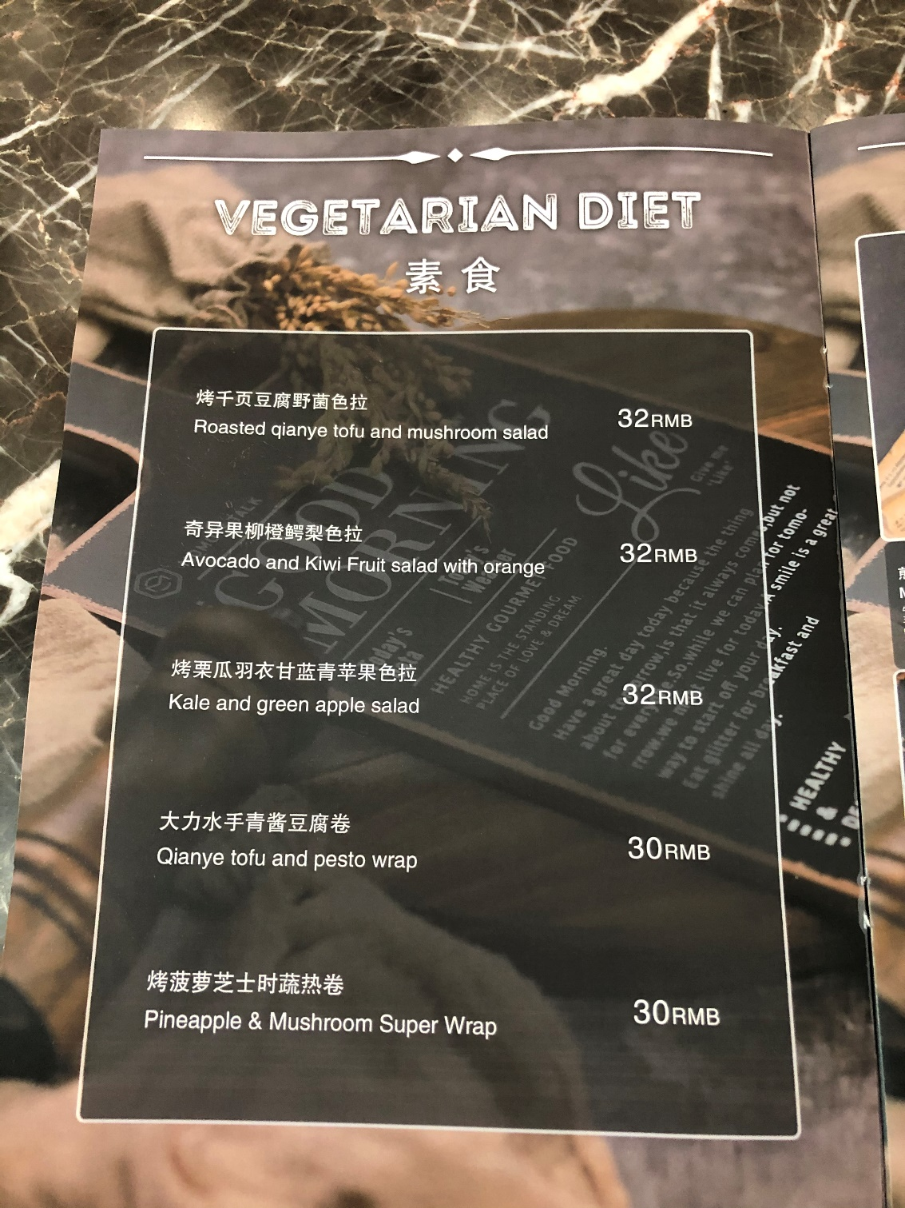
Photo 3: The canteen with which the students collaborated on “Meatless Mondays in March” created a permanent vegetarian menu after seeing the demand during the campaign.
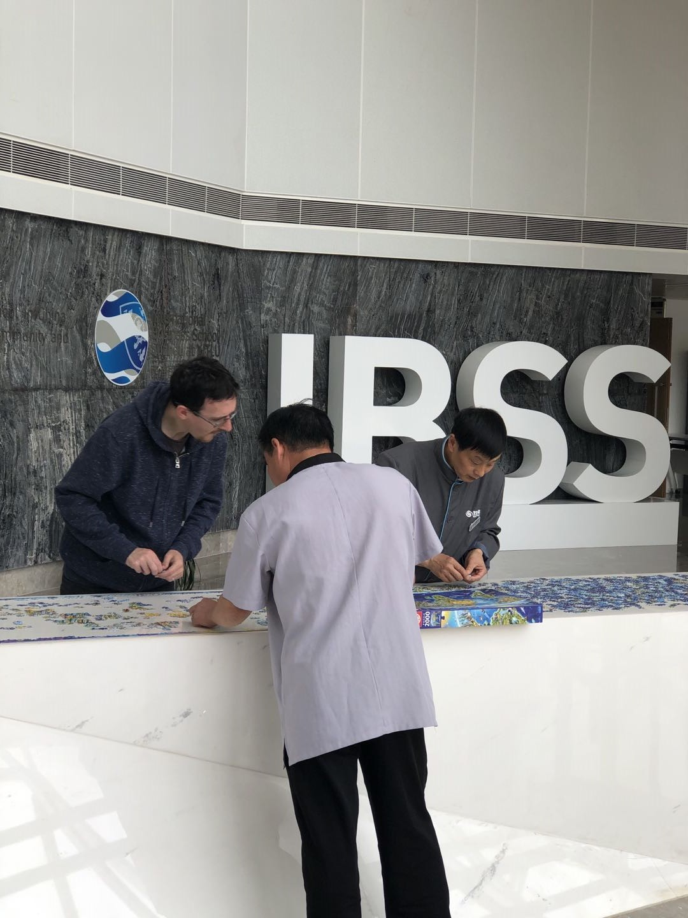

Photo 4: Faculty, security and custodial staff all worked together on the environmentally-themed puzzles.
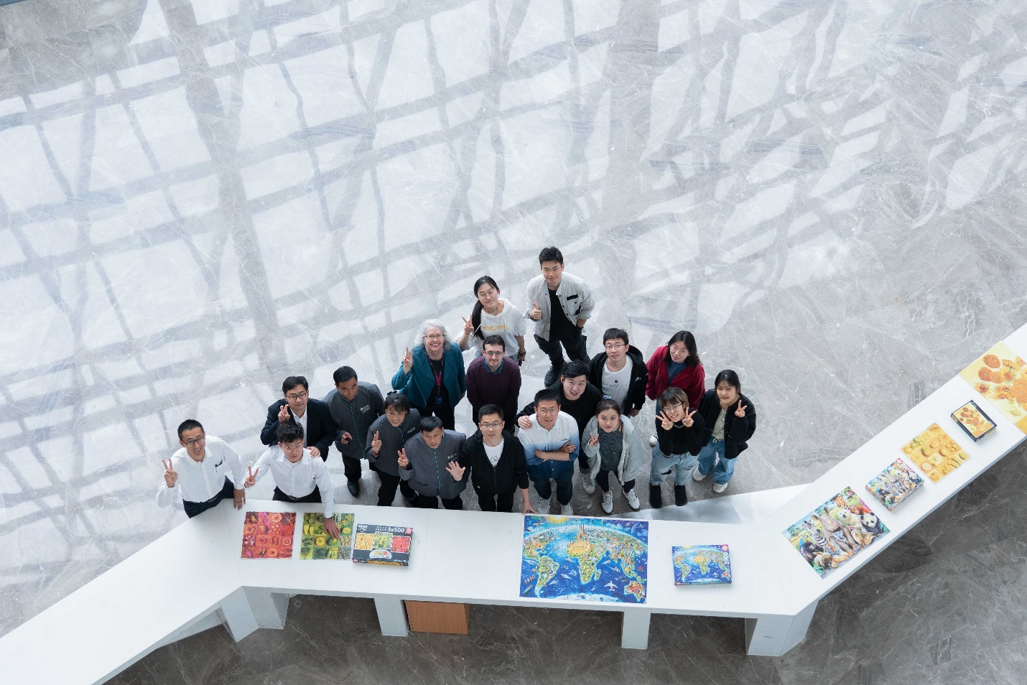

Photo 5: Multiple stakeholders worked together to complete the puzzles during Midterm Week.
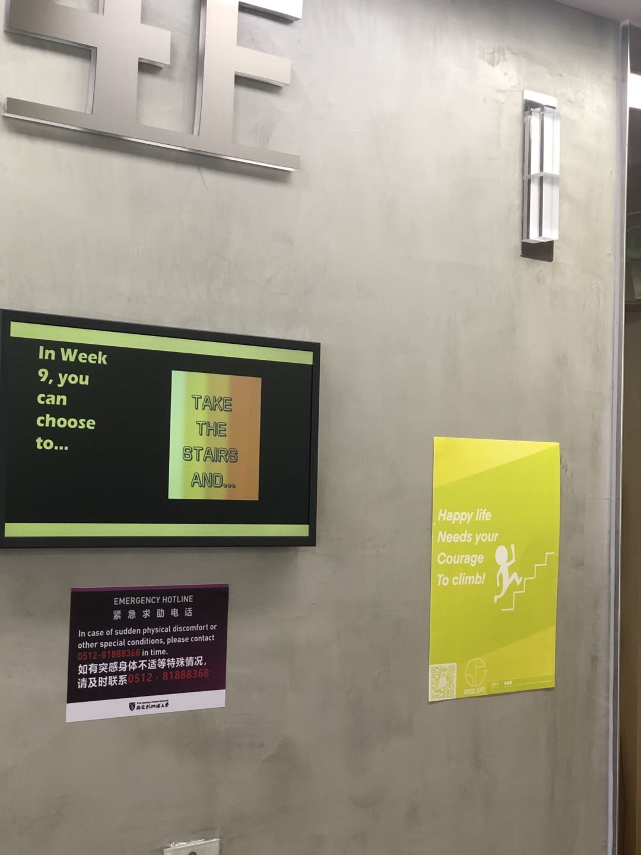
Photo 6: Posters and prizes were distributed throughout IBSS to encourage sustainable mobility choices.

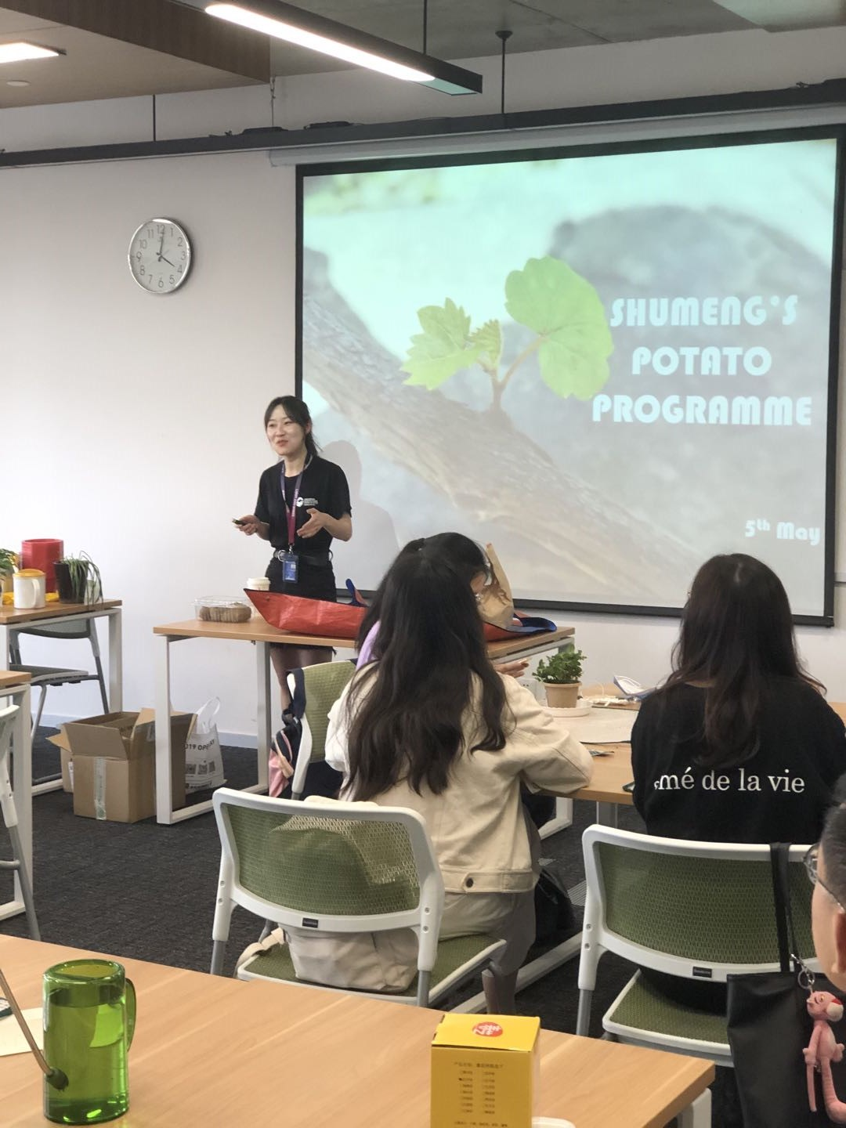
Photo 7: A staff member shared her love of gardening with IBSS.

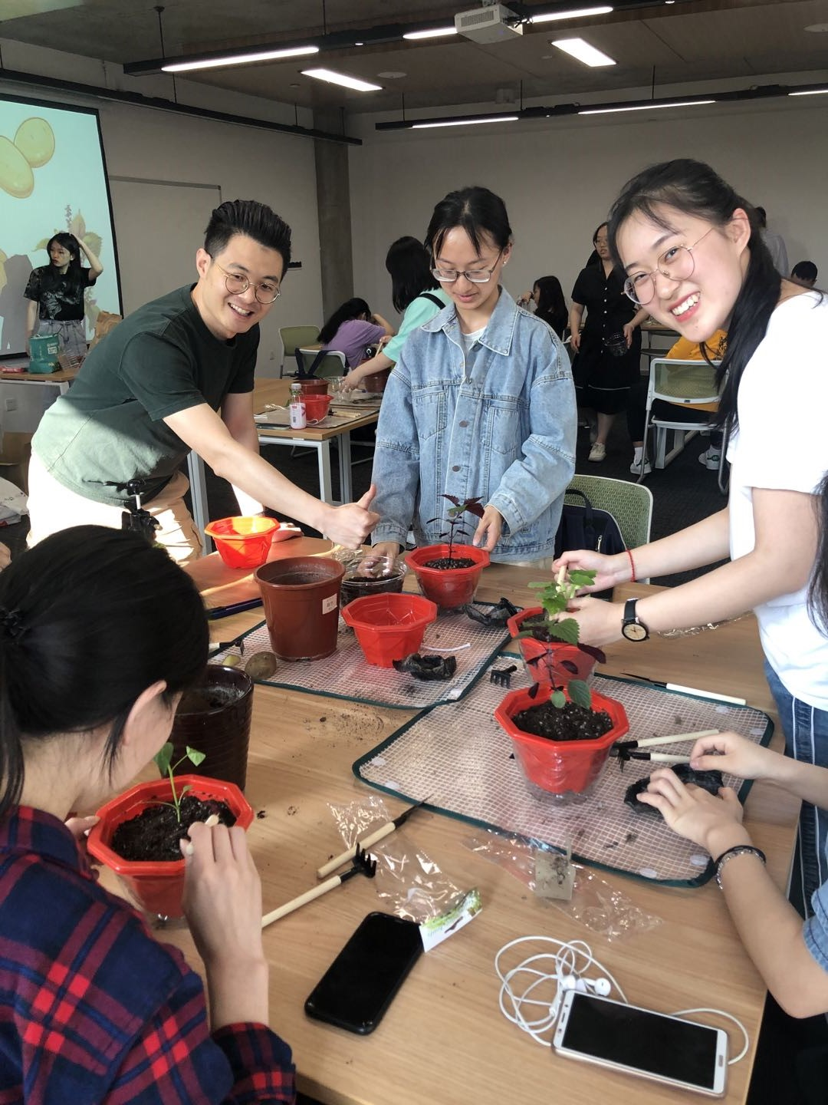
Photo 8: Faculty, staff and students plant potatoes to “grow your own”.

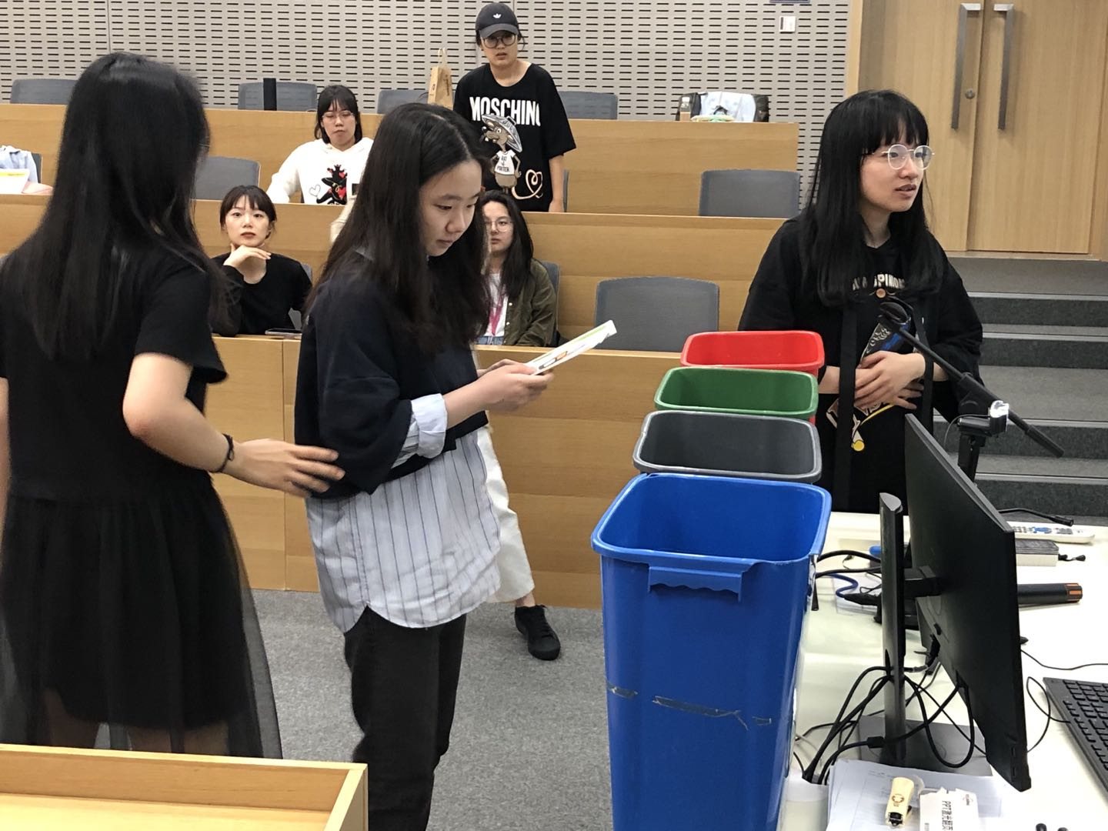

Photo 9: Local community leaders lead our students in a waste-sorting workshop.

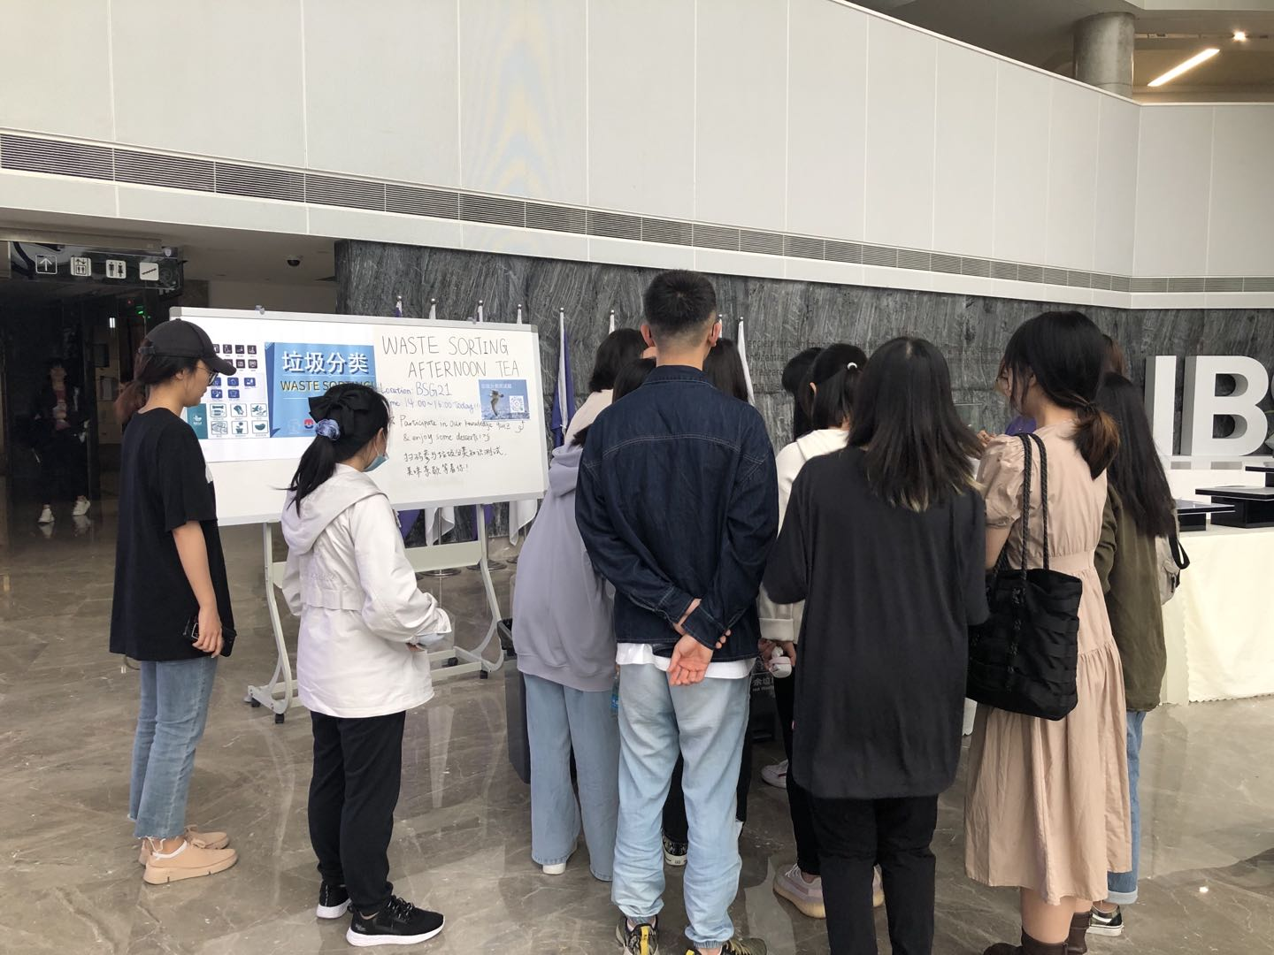
Photo 10: Waste-sorting workshop is followed by an afternoon tea during which students put this knowledge to use by sorting the waste.

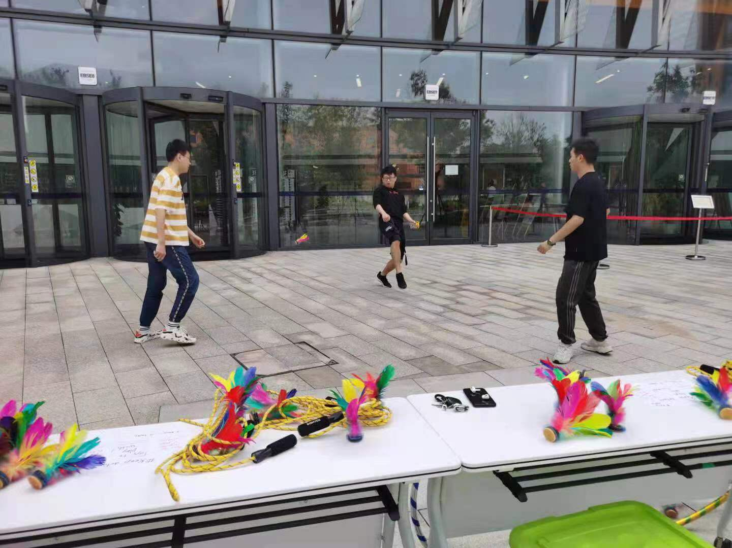
Photo 11 : Students relieve stress by playing childhood games on the plaza.
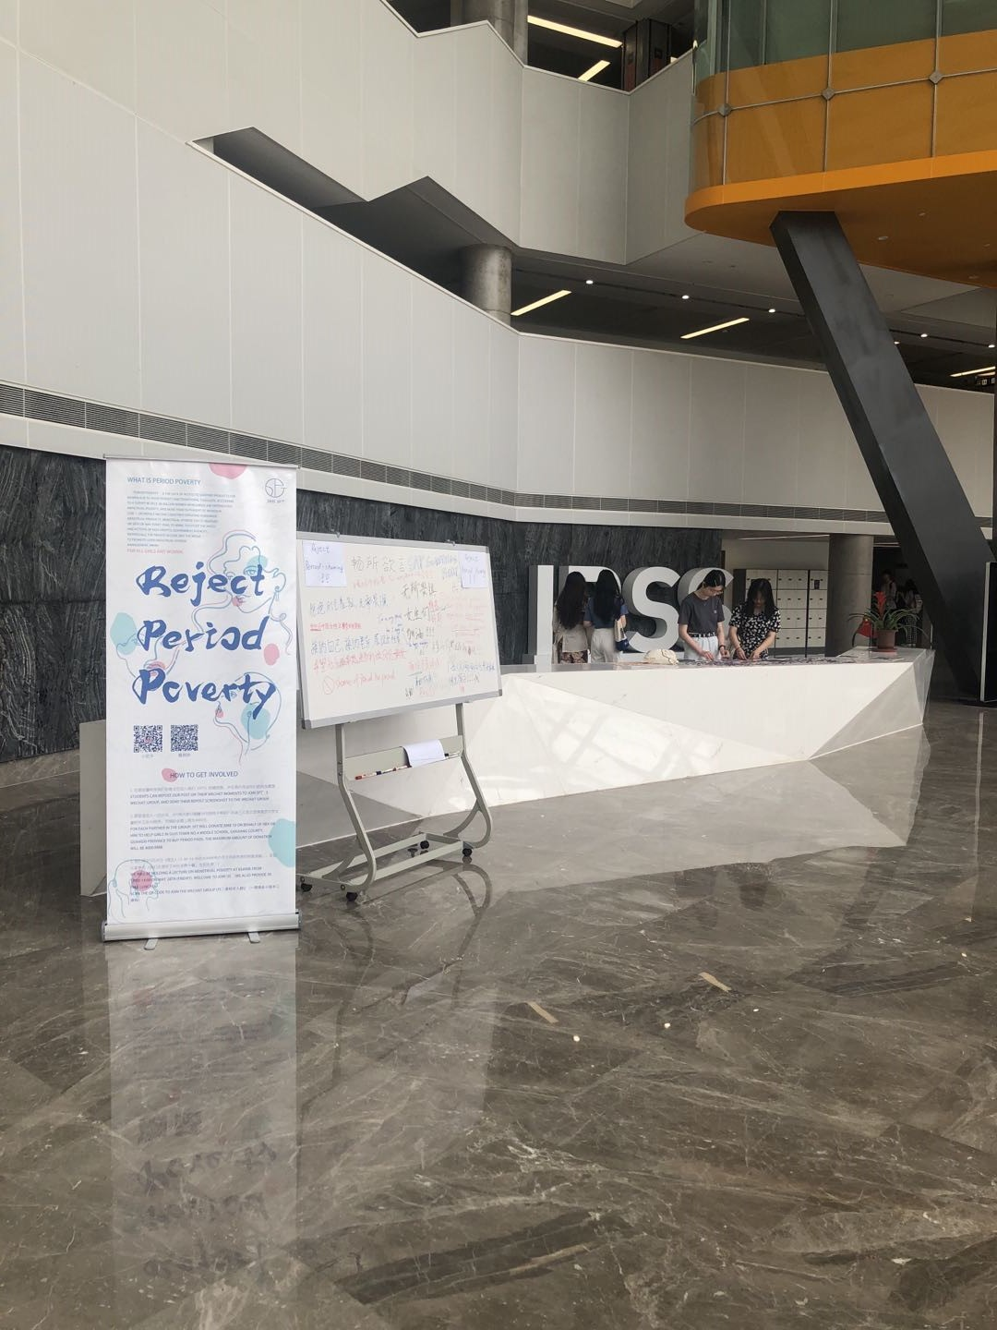
Photo 12: Week 13 also marked Menstrual Hygiene Day (May 29) with consciousness-raising activities.
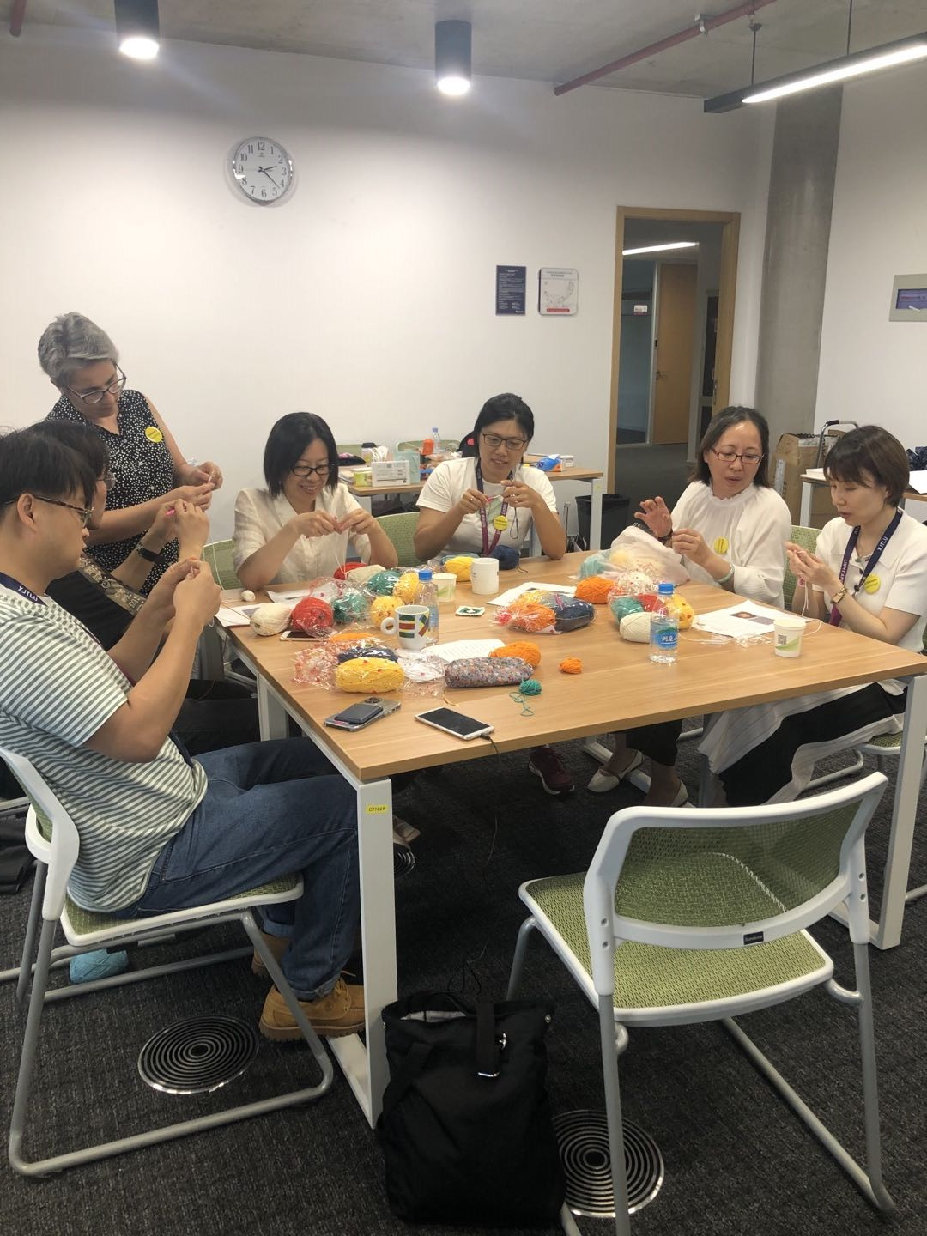
Photo 13: Members from Tang MaMa charity teach our faculty, staff and students how to crochet to create their own “slow fashion”.

